Griffin Rzonca

ECE 445

10/29/23

Safety Training and Notes

* The following are images and key takeaways from the required safety training, and things we want to keep in mind when building and testing our design
* Also, consider adding safety stickers or labels to project to indicate hazard

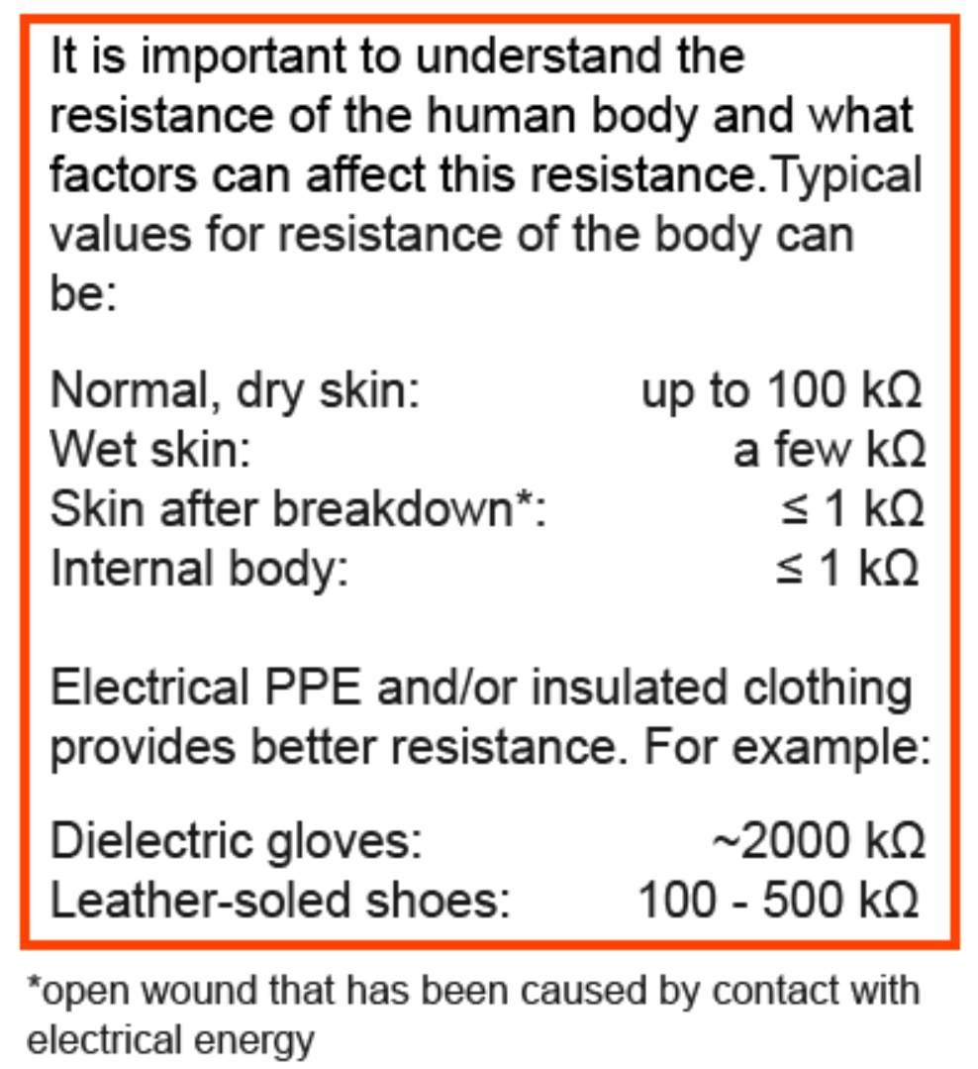

Source: [Electrical Safety: Fundamentals (illinois.edu)](https://captivate.research.illinois.edu/289/index.html)

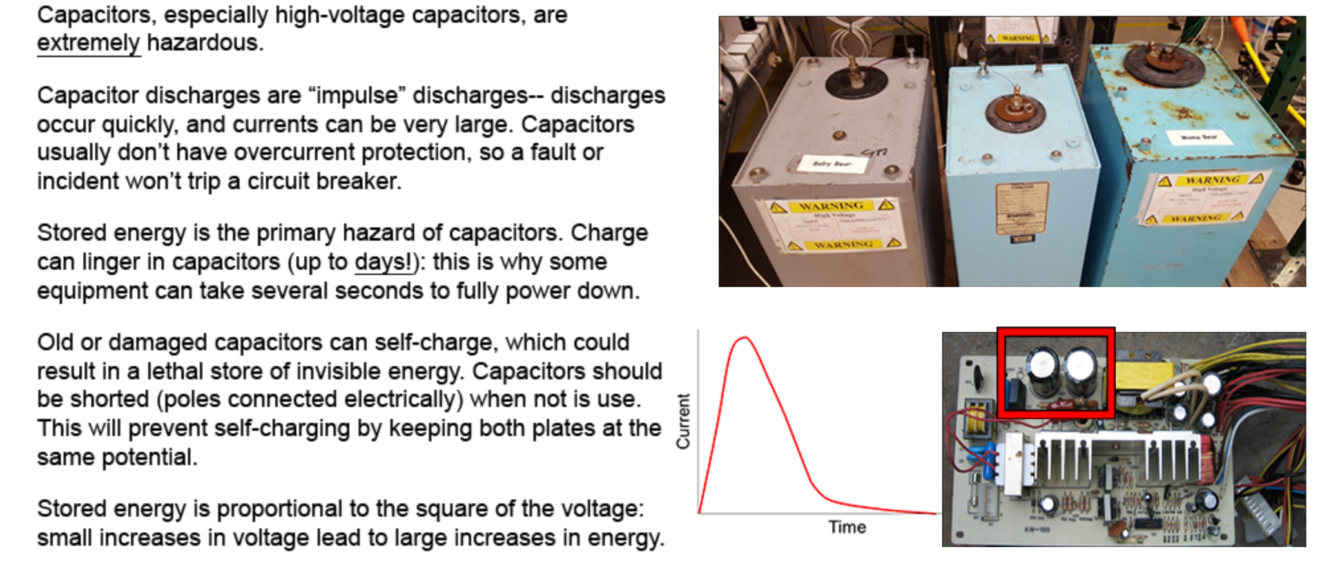

—---------------------------------------------------------------------------------------------------------

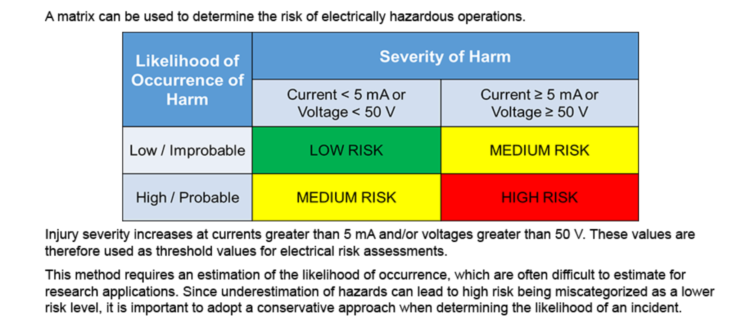

Source:[Electrical Safety: Risk Assessment (illinois.edu)](https://captivate.research.illinois.edu/290/index.html)

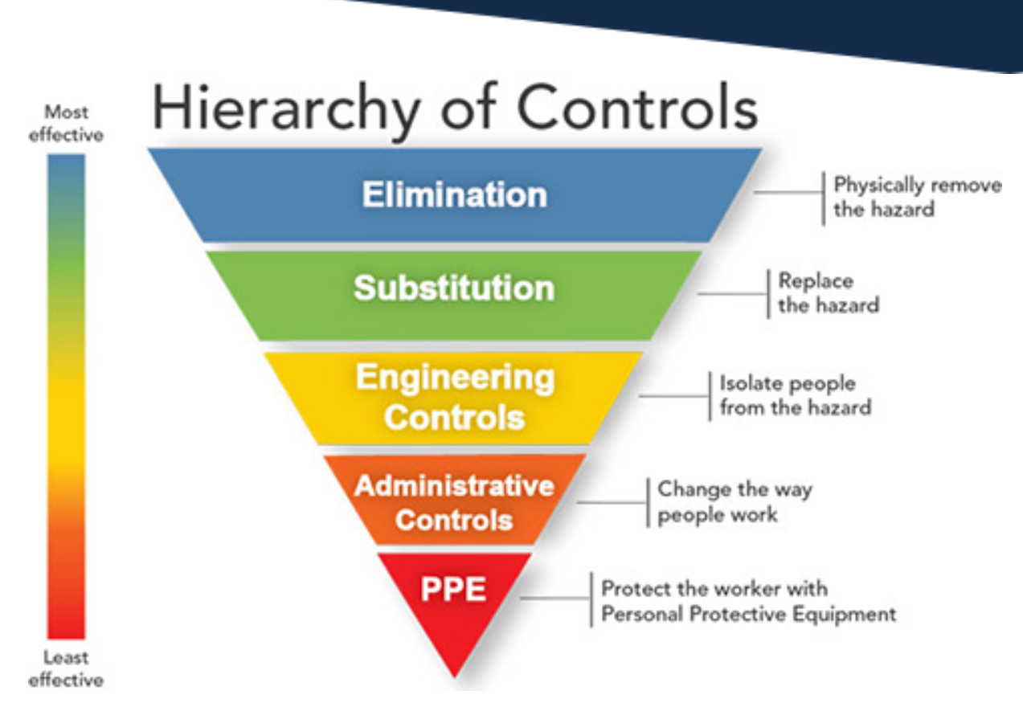

* DRS Template for safe operation:
  + [Electrical_Risk_Assessment_Template_Fillable.pdf (illinois.edu)](https://captivate.research.illinois.edu/290/Electrical_Risk_Assessment_Template_Fillable.pdf)

—-------------------------------------------------------------------------------------------

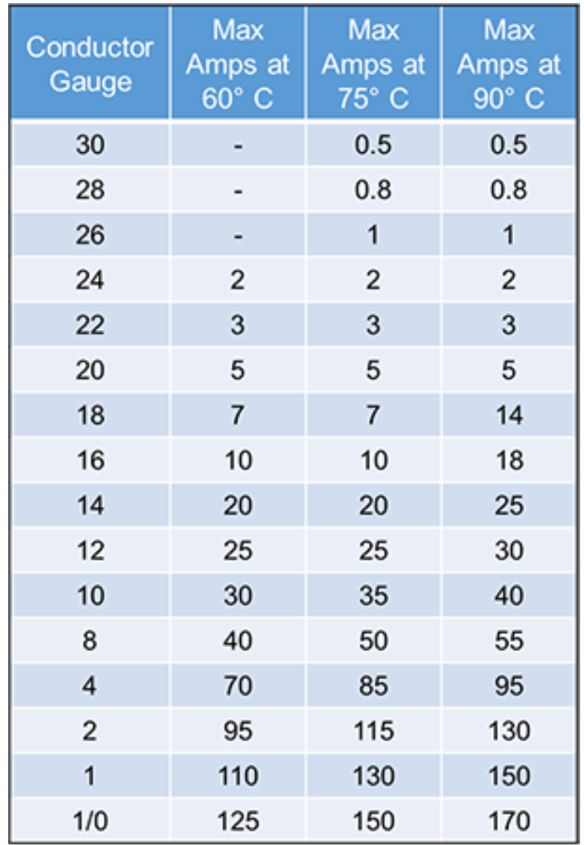

Source: [Electrical Safety: Recommended Practices (illinois.edu)](https://captivate.research.illinois.edu/291/index.html)

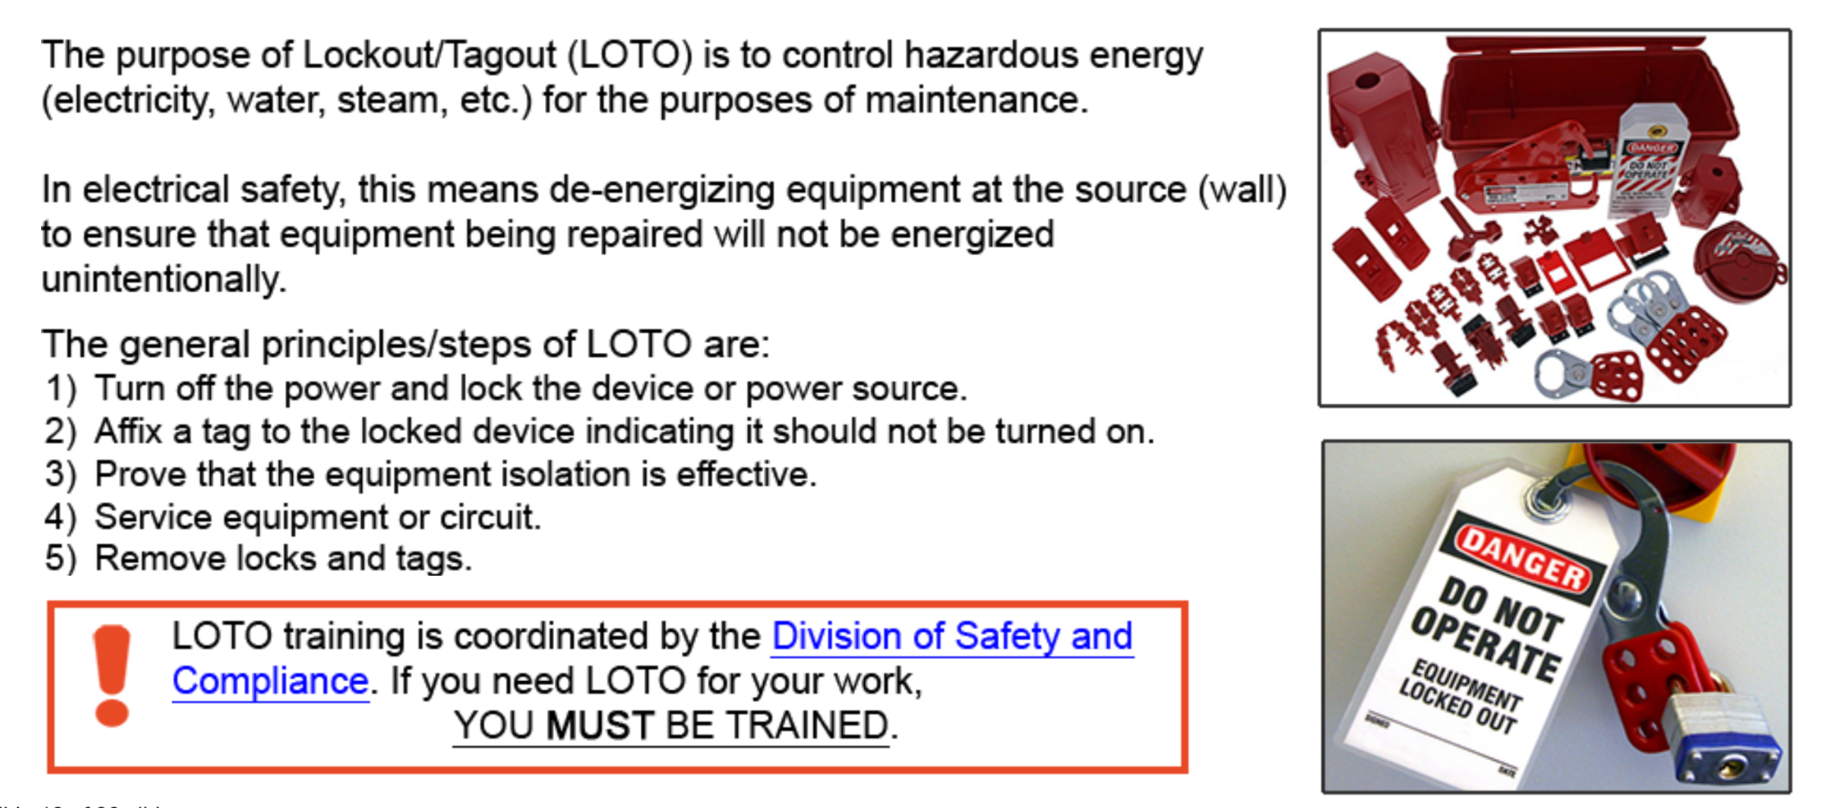

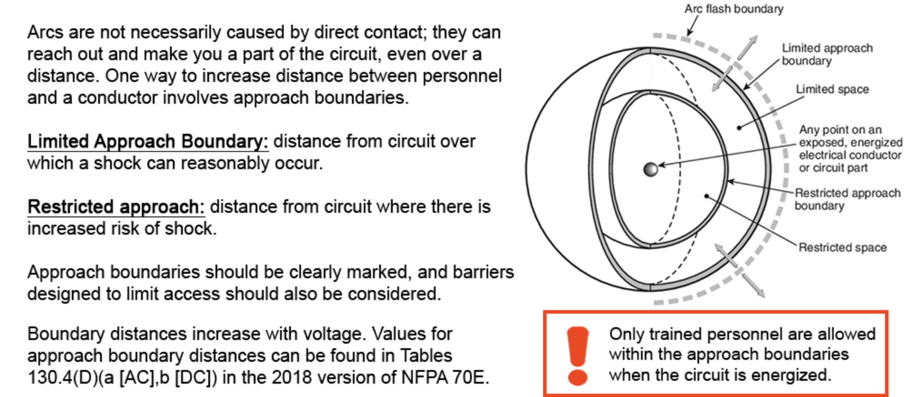

* Can include data from code listed in future reports or presentations

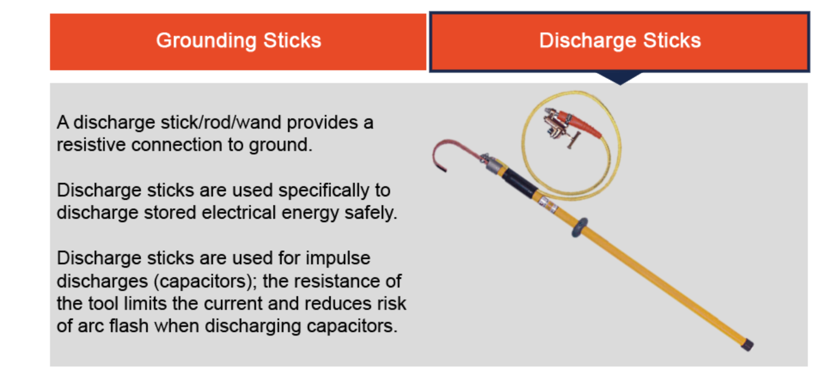

* Can use this or bleeder resistors for our capacitors